Reasoning Flaws and Analytical Inconsistencies
Why Praxis Precision Pharmaceuticals’ ulixacaltamide will fail its Phase 3 Clinical Trial

By Snaking
December 2024

Executive Summary
In this work, I will prove that the ESSENTIAL3 Phase III trial will fail to meet its primary endpoint. In the subject of clinical trial analysis, proving is much more complicated than hypothesizing. Occasionally, though, deterministic claims can be made.
Praxis Precision Pharmaceuticals is not a one-asset company, therefore the effect of a failed clinical trial on the stock’s share price won’t be as magnified as ideally.
In a Phase 2b clinical trial, the data showed conflicting numbers with benefits in subjective items, while showing significant impairments in the objective criteria.
It is important to remind the reader that the criteria used to evaluate efficacy in this Phase 3 clinical trial is entirely patient-reported, which I believe to be a preposterous design. With this in mind, limited linearity between Phase 3 results and drug efficacy are to be considered. I will prove that, even with this condition, Phase III readout will not be positive.
Readout is expected to be in Q1 2025. The company has a cash value of $19,31 per share, and other phase 2 and 3 clinical trials on the day. I will limit the expected stock price decrease to 60%, closely related to what was previously seen after Phase 2b data readout (65%).

Phase 2b: Wishful Analysis of Failed Trial
Phase 2b results showed effective in mADL1-11 items, while presenting impairments in TETRAS-PS items 6 and 7, the only TETRAS-PS criteria included.
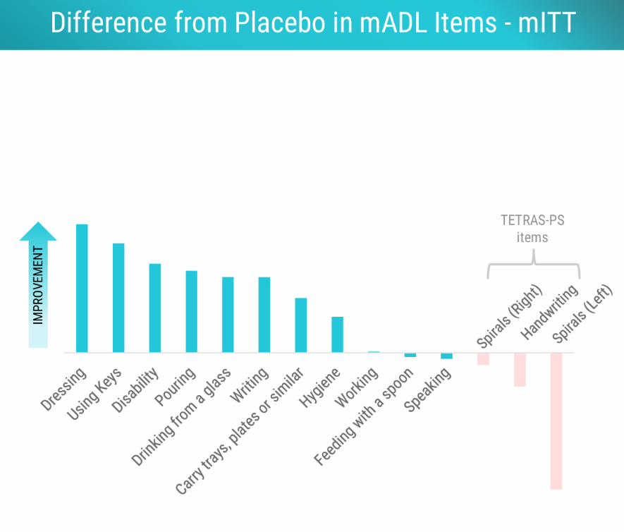
Without further knowledge, this alone doesn’t give justice to the implausibility of the claim that this drug could have had any sort of positive effects in patients.
Modified Activities of Daily Living 1 through 11, mADL1-11, is a scale that measures ability to engaging in routine tasks, such as “Dressing”, “Writing”, “Using Keys”, … This scale is entirely patient reported, adding a layer of subjectivity to the readability of the scale.
The Essential Tremor Rating Assessment Scale Performance Scale, TETRAS-PS, is a scale designed to quantify essential tremor severity based on estimates of peak-to-peak tremor amplitude, not on subjective anchors such as “normal, mild, moderate and severe”, which are biased by the variable clinical experience of examiners.1
It is very clear to me that if ulixacaltamide offered any true benefits in Essential Tremor, such a well-powered study would not show contradictions between the two scales. If anything, we should rely on the objective TETRAS-PS items 6 and 7 (Spirals and Handwriting) more than the subjective ones.

The company decided to proceed with a Phase 3 trial with primary endpoint mADL11, after making the post-hoc observation that removing TETRAS-PS items 6 and 7 would lead to a significant nominal p value if no further corrections were to be applied.

